Protocol Races
[§10.4] We have assumed—
- Directory state reflects the most up-to-date state of caches.
- Messages due to a request are processed atomically.
In reality, one of or both conditions may be violated
- Protocol races can occur
- Some protocol races can be handled in a simple way; others are trickier.
We will discuss how protocol races can be handled.
- Purpose of discussion: illustrate approaches for dealing with protocol races.
- Discussing all possible races is not the goal.

Handling races: out-of-sync directory
[§10.4.1] Suppose the home sends an invalidation to a node that has replaced the block silently.
- The node can reply with
Suppose that the home receives a read request from a node that is already a sharer from the home point of view.
- The directory can reply with data
Suppose that the home receives a read/write request from a node that the home thinks is the owner.
- (In the directory, what state is this block in?)
- What might have happened to the block?
  - If the block was clean,
  - If the block was dirty,
    - What should the home do? (Why will neither of these work?)
  - Wait?
  - Reply with data?
- The directory alone cannot resolve this. Coherence controllers at other nodes must participate in the solution.
- What does the coherence controller at a node n need to do when a flush or writeback occurs?
  - Maintain an outstanding transaction buffer (OTB) for flush messages.
  - Require the home to acknowledge the receipt of a flush
- These two steps allow node n to delay a Read/ReadX request to a block that is still being written back.
- Hence, the home only receives Read/ReadX to a block that is not being written back.
  - When it does, it can send a

Protocol modification
Here is a modified state-transition diagram.
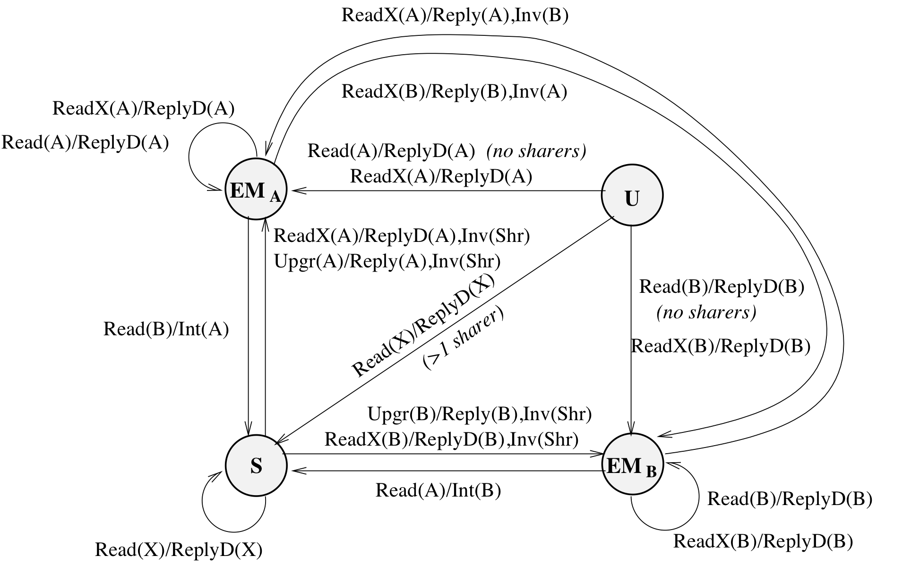
What is the meaning of “owner” in a directory protocol?
The meaning of “owner” is ambiguous here …
- because the directory may be out of sync with cache states,
- the directory may get a Read or ReadX from a node it thinks is the owner (but actually isn’t).
(This isn’t permitted by the protocol.)
What do we do about it?
- Split EM into two states (EM_{A} and EM_{B}) to reflect this situation.
- EM_{A} means the directory thinks the current owner is A.
- EM_{B} means the directory thinks the current owner is B.

Transitions from state U
Suppose the block is in state U in the directory.
- What happens on a ReadX request?
  - The system fetches the block from the local memory, sends a ReplyD to the Requester, and moves to state
- What happens on a Read request?
  - The system
  - What state does the requesting cache transition to?
  - What state does the directory transition to?

Transitions from state S
Suppose the directory state is S.
- What happens on a Read request?
  - The directory knows it has a valid block in the local memory.
  - It sends a to the Requester and updates the sharing vector.
  - Directory state
- What happens on a ReadX request?
  - Directory sends to the Requester.
  - Directory sends to all (other) sharers.
  - State changes to
  - But, if it’s an upgrade, it just

Transitions from state EM
Suppose WLOG the directory state is EM_{A}.
Suppose a Read request (from a different node B) is received.
- The state is set to
- An is sent to the owner (A) to change its state to
Suppose a ReadX request (from a different node B) is received.
- Directory sends an invalidation message to
- This message also says to send the data to
- Directory sends a reply message to B, saying that will supply the data.
- State transitions to
- (Note that it doesn’t matter whether owner is in state E or M.)
Suppose the directory has an out-of-sync view of cache states, and is in state EM_{A}.
- Suppose it receives a Read or ReadX from A.
  - This means A’s block must’ve been replaced due to a cache miss.
- The directory knows that A is really the owner.
- Thus, it can just respond with

Handling races: non-atomic messages
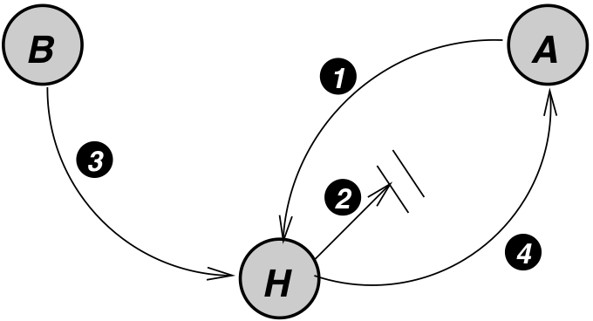
- [§10.4.2] A sends a read request to home.
- Home replies with data (but the message gets delayed).
- B sends a write request to home.
- Home sends invalidation to A, and it arrives before the ReplyD
Why is this a problem?
This is called an “early invalidation” race.

How should A respond to the invalidation?
Two incorrect ways to respond:
- A replies with InvAck.
  - B thinks that its write propagation is complete
  - A receives a ReplyD and places the block in its cache (the block that should have been invalidated).
- A ignores the invalidation message
  - The message is lost; write propagation has failed to occur
Solution:
- Brute force (avoids overlapped handling of requests):
  - Home waits until it receives ack from all parties (home-centric)
- Allow overlapping but ask nodes to participate (requester-assisted)
  - Node keeps an OTB
  - It does not entertain requests (to the same block) until the current transaction is completed

Exercise: Explain how each of these scenarios would play out using the four-step diagram above.

Processing a Read Request
Case 1: Read to clean block
Home-centric approach
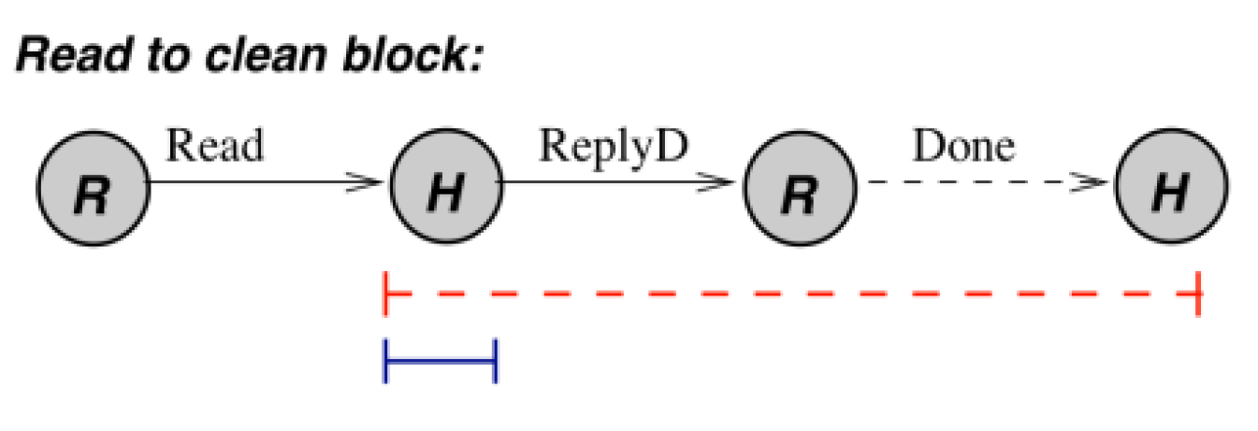
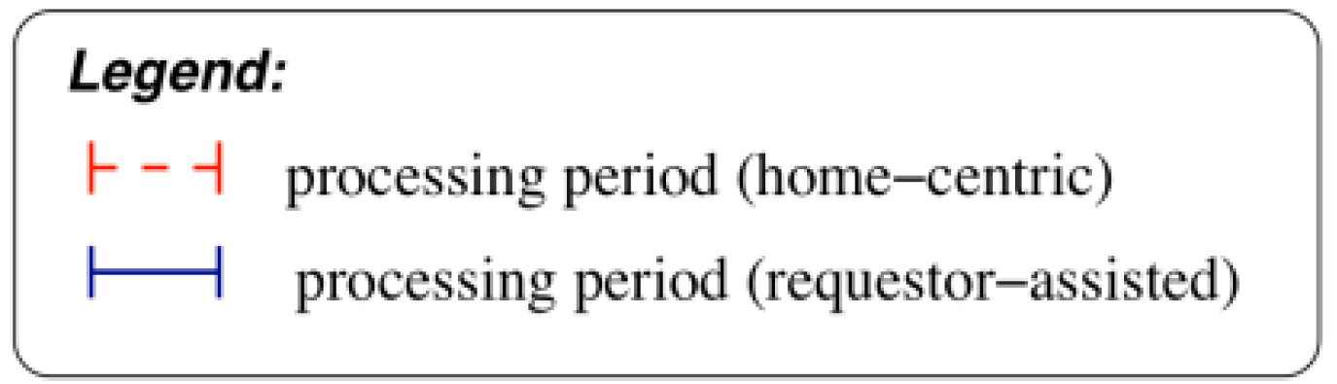

- Directory enters a transient state.
- Home replies with data
- Requester receives data, sends ack to home.
- Home closes transaction (transitions to a stable state, update sharing vector).
Cons: too much serialization at home, transaction closed late, and it requires ack
Requester-assisted approach
- Directory sends ReplyD, then closes transaction
- Requester buffers/nacks all new requests until ReplyD received (i.e., till the current Read transaction is completed)
Case 2: Read to block in EM state
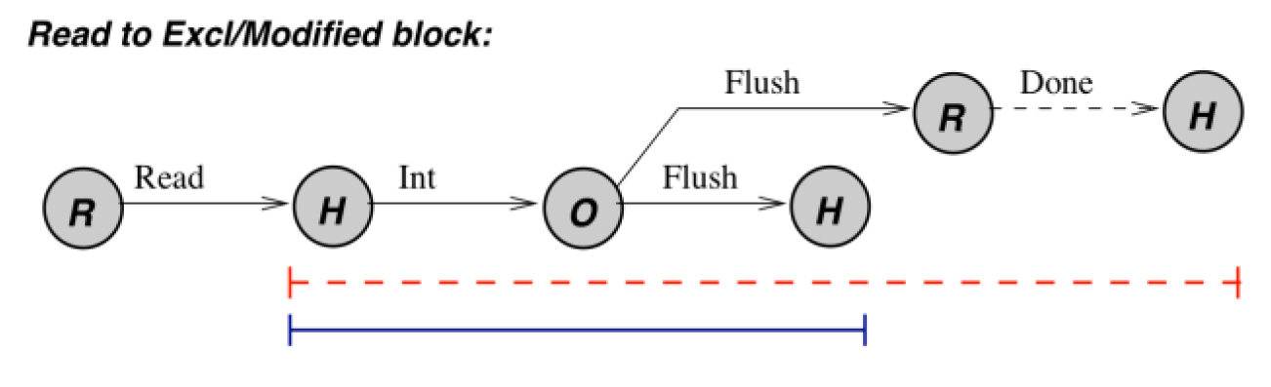
Home-centric approach
- Requester sends Read to home
- Home enters a transient state, sends intervention to owner
- Owner flushes block to home and requester
- Requester sends ack back to home
- Home closes transaction (transitions to shared state, updates sharing vector)

Requester-assisted approach
- Requester sends Read to home
- Home enters a transient state, sends intervention to owner
- Home cannot close the transaction yet, because in the final state (Shared), it must have a clean copy of the block
- Owner flushes block to home and requester
- Upon receiving the block from owner, home closes transaction

Processing a write (ReadX) request
We will cover this in the next class.

Write Propagation and Serialization
[§10.4.3] In a directory-based protocol,
- Write propagation is achieved through invalidation.
- Multiple writes to a block are serialized by the protocol.
- Transaction closes after the ack from current owner is received by home.
- A new ReadX request is not served until the previous ReadX request is closed.
- This provides write serialization
Here is a diagram of serializing writes by A, B, and C.

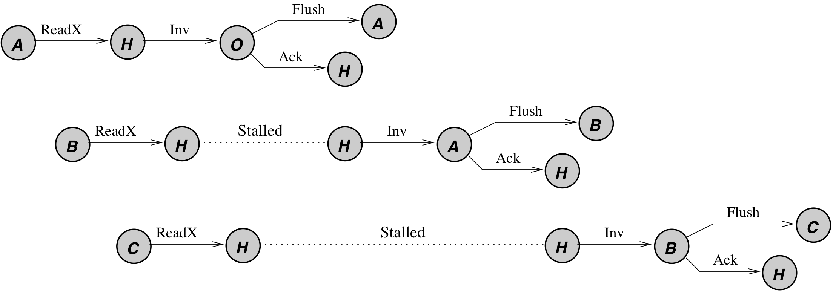
Is it using the home-centric or requester-assisted scheme?

Memory consistency models
[§10.4.5] Implementing sequential consistency:
All memory accesses by a processor must be issued and completed in program order.
Which of the two (issuing or completion) is hardest to assure?
- Write completion detected when all InvAcks are collected
- When does read completion occur?
- Prefetching and load speculation can be used.

As the number of processors grows,
- Average latency of a cache miss increases
- Harder to hide it
- What does this do to the viability of SC?

